COGNIZANT_DN 4.O-DEEP SKILLING

WEEK 1 MANDATORY HANDS_ON

JEEVADHARSHINI B

ST.JOSEPH’S INSTITUTE OF TECHNOLOGY

Week 1

Design patterns and principles

EXERCISE 1: **Implementing the Singleton Pattern**

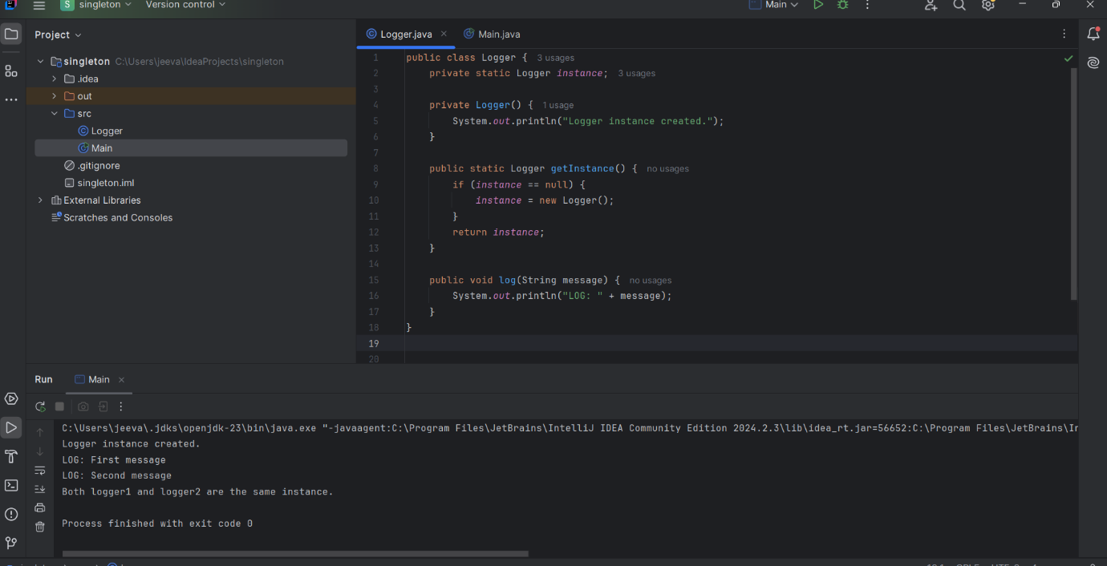

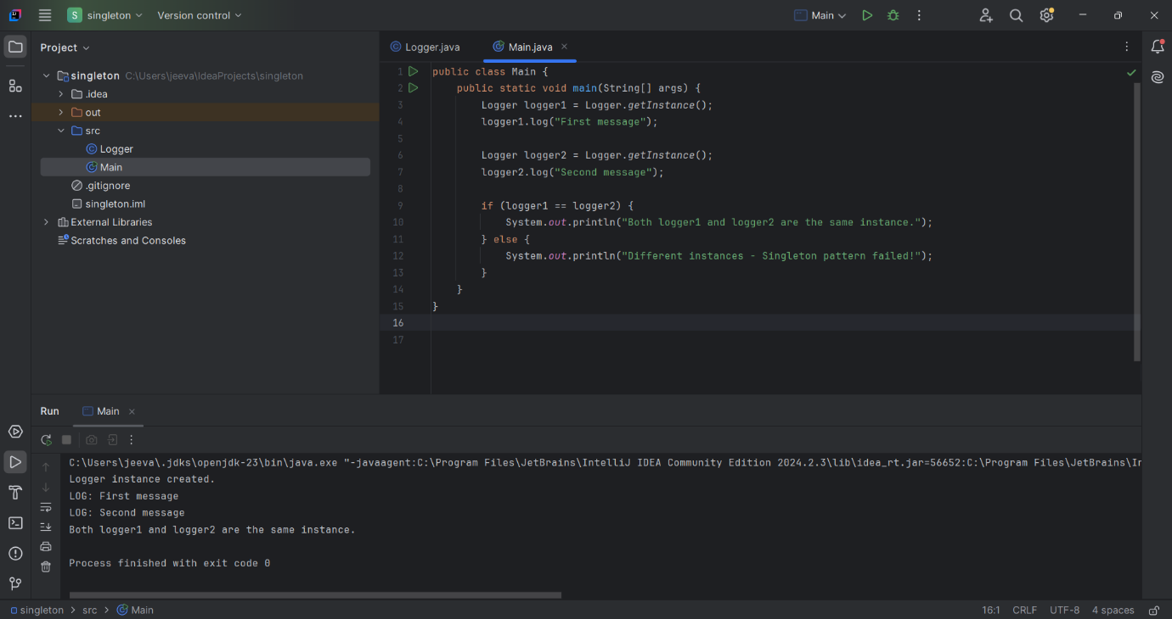

EXERCISE 2: **Implementing the Factory Method Pattern**

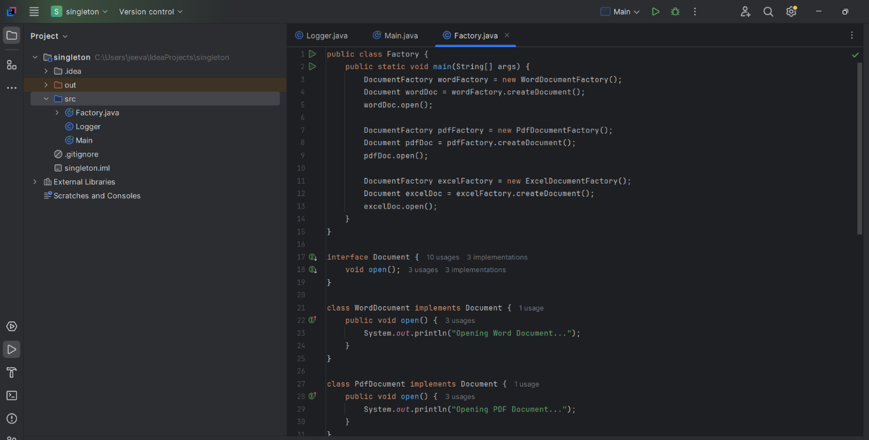

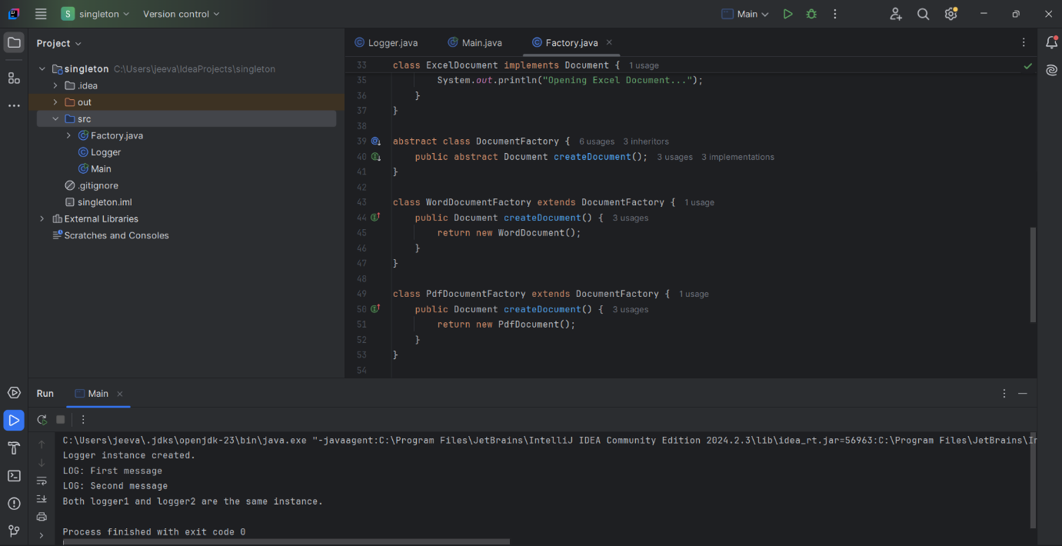

Week 1

Algorithms_Data Structures

EXERCISE 1**: E-commerce Platform Search Function**

1)Asymptotic Notation

Big O Notation:

* Describes how the running time of an algorithm grows as input size (n) increases.
* Helps us compare efficiency of algorithms.
* Example:
  + Linear search → O(n)
  + Binary search → O(log n)

2)Best, Average, Worst Case:

* Linear search:
  + Best → O(1) (found at first element)
  + Average → O(n/2) ~ O(n)
  + Worst → O(n) (last element or not found)
* Binary search:
  + Best → O(1) (middle element first)
  + Average & Worst → O(log n)
  + Requires sorted data

SETUP

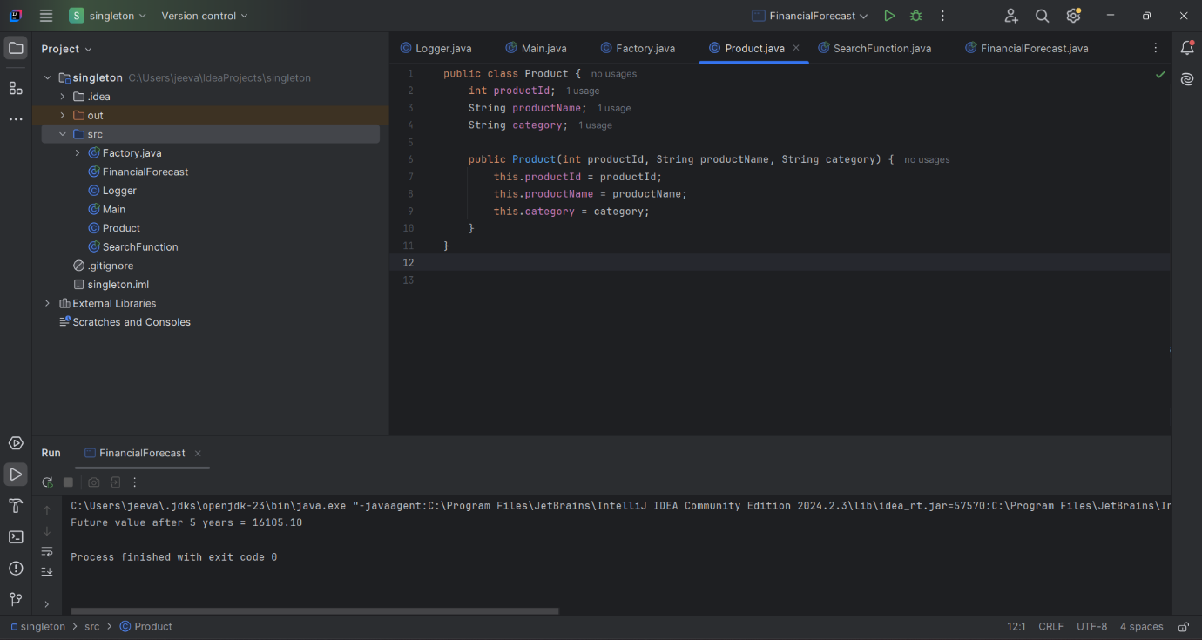

Linear Search & Binary Search Implementation

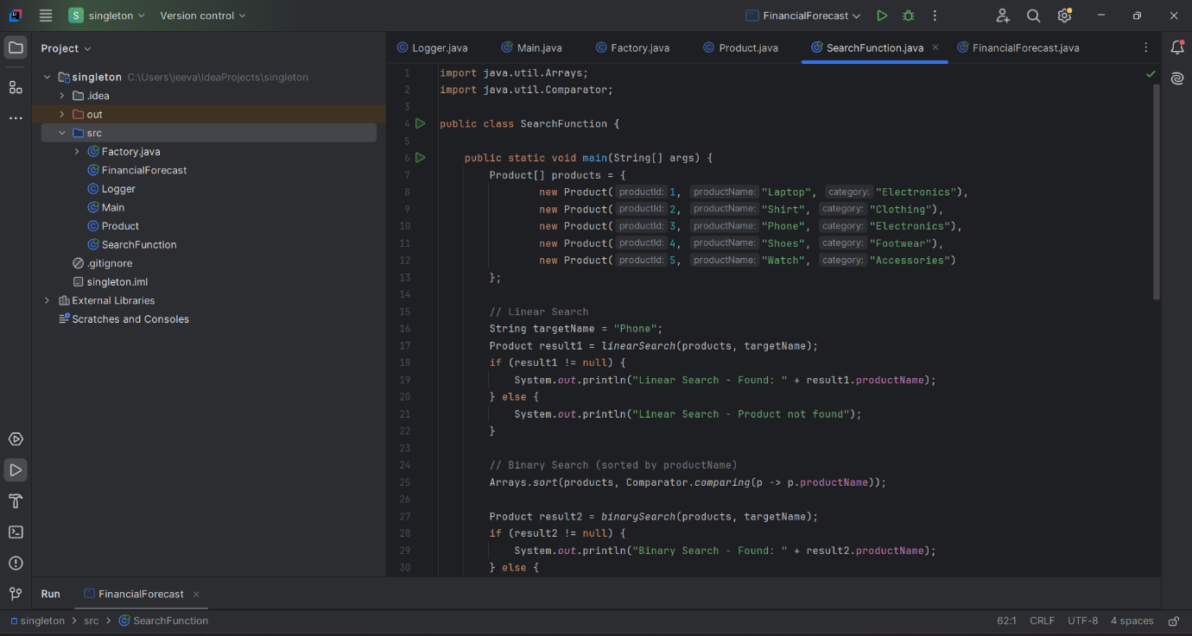

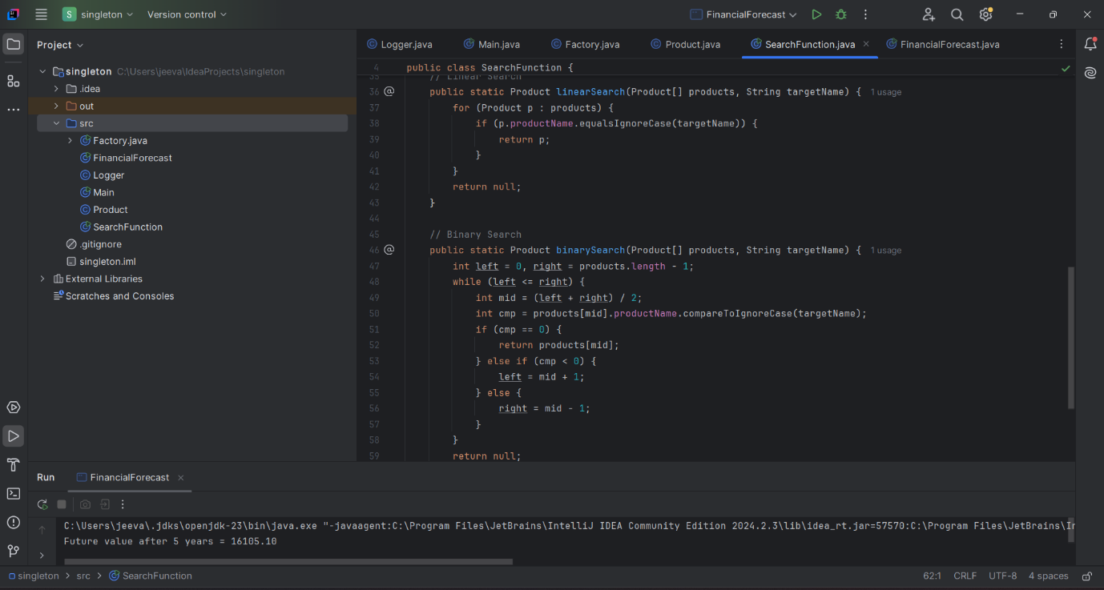

EXERCISE 2: **Financial Forecasting**

